Model Performance Report
Several machine learning models were tested on the Nigerian 7 Conditions dataset. This dataset contains symptoms as input features and the target is the disease diagnosis (7 possible conditions). The goal was to see which models performed best by comparing their accuracy and confusion matrices.

Confusion Matrices Overview
This grid shows confusion matrices for six different models trained on your dataset. Each confusion matrix is basically a table that compares the true labels (actual diseases) against the predicted labels (what the model predicted).
- Diagonal cells (top-left to bottom-right): Correct predictions
- Off-diagonal cells: Misclassifications (where the model guessed the wrong disease)
- Legend bar: Darker shades mean higher number of cases

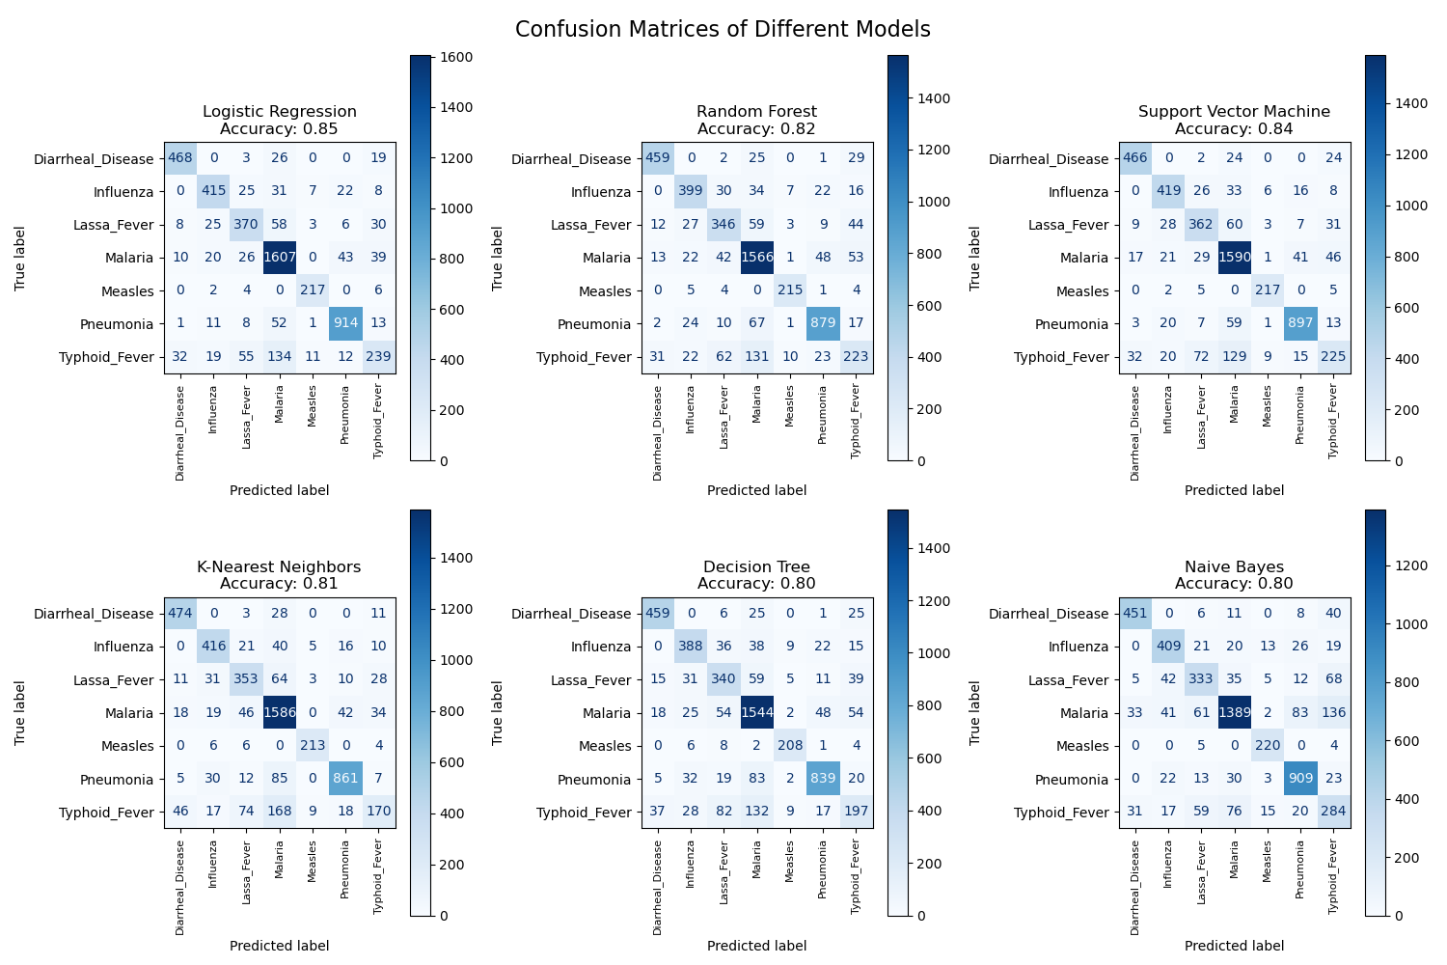

Model Observations

Logistic Regression
Accuracy: 0.85
Logistic Regression performed very well. It handled most diseases quite well, especially Malaria and Pneumonia, but there were some misclassifications with Lassa Fever and Typhoid Fever. Overall, a solid and interpretable model.

Random Forest
Accuracy: 0.82
Random Forest gave consistently good results. It captured non-linear interactions between symptoms, but showed some confusion between diseases with overlapping symptoms (like Typhoid and Malaria). It’s a strong, balanced model overall.

Support Vector Machine
Accuracy: 0.84
SVM did very well, almost on par with Logistic Regression. It was strong on the big classes like Malaria, but still showed some struggles on smaller ones like Measles.

K-Nearest Neighbors
Accuracy: 0.81
KNN worked reasonably well but tended to confuse diseases with similar symptom patterns. It’s simple and intuitive, though not the most efficient for large datasets.

Decision Tree
Accuracy: 0.80
The Decision Tree was okay but slightly less accurate. It tends to overfit, which explains why it struggled on the test set compared to Random Forest.

Naive Bayes
Accuracy: 0.80
Naive Bayes was the weakest of the group. It assumes independence between symptoms, which isn’t realistic here, leading to mistakes especially for overlapping symptom diseases.

Key insights & Conclusion
Overall, Logistic Regression and SVM performed best in terms of accuracy. Random Forest also stood out for its balanced performance. If we had to pick one for deployment, Random Forest would be a safe choice because of its robustness (because it reduces many of the weaknesses of a single Decision Tree, especially in this case where the data is not organic, it reduces noise), but Logistic Regression is also great due to its simplicity and high accuracy.
Class imbalance effect: Common diseases (Malaria, Pneumonia) dominate performance i.e., all models predict them well. While rare diseases (Measles, Lassa fever) were harder to detect, often confused with similar-symptom conditions.

